KOSGEB Entrepreneur Support Program from Idea to Market

KOSGEB Entrepreneur Support Program from Idea to Market

Dr. UÄŸur CORUH



## Download Files

* [PRESENTATION](girisimcilik-giris.pdf)
* [DOCUMENT](pandoc_girisimcilik-giris.docx)

# KOSGEB Entrepreneur Support Program from Idea to Market

### **What is a project?** â†’ **Why should you get support?** â†’ **How do you start?** â†’ **Develop, Grow, Commercialize!**

Learn the steps to grow your business with a project!

){height=100](assets/rteu_logo.jpg)}

Dr. UÄŸur CORUH

* Coruh Arge ve Teknoloji, General Manager
* Recep Tayyip ErdoÄŸan Uni. Department of Computer Engineering, Dr. Lecturer



## 1. What is a Project and Why is it Important?

### Question: What is a project?

* **Answer**: A project is a planned effort to achieve a specific goal. Projects are carried out to grow your business, offer new products, or increase efficiency.
  + Purpose
  + Goal
  + Plan
  + Action
  + Result

### Project Elements

* **Project Purpose**  
  The general purpose of the project is to solve the targeted problems or seize opportunities.
* **Project Objectives**  
  Specific and measurable outcomes of the project.
* **Project Innovation Value**  
  What makes your project innovative and unique compared to other projects?
* **Project Duration**  
  Estimated start and end dates of the project provide information about the duration.
* **Project Team**  
  Roles and areas of expertise of those contributing to the project.
* **Project Budget**  
  The cost and budget items of the project.
* **Project Methods and Application**  
  What methods and strategies will the project be carried out with?
* **Project Outputs**  
  Outputs and results to be obtained when the project is completed.

### Example Project Plan (Gantt Chart)

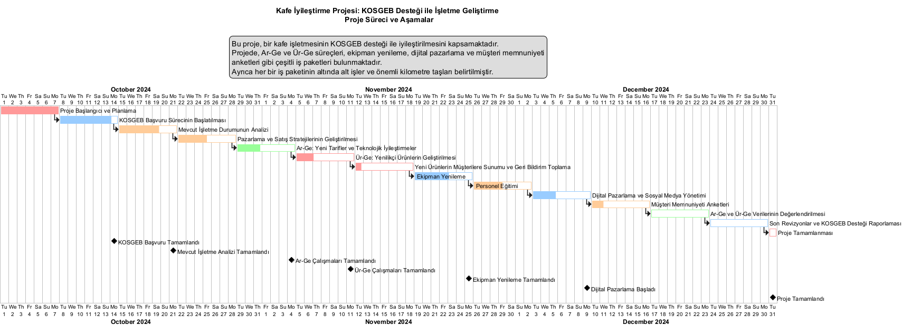

### Technology Readiness Levels

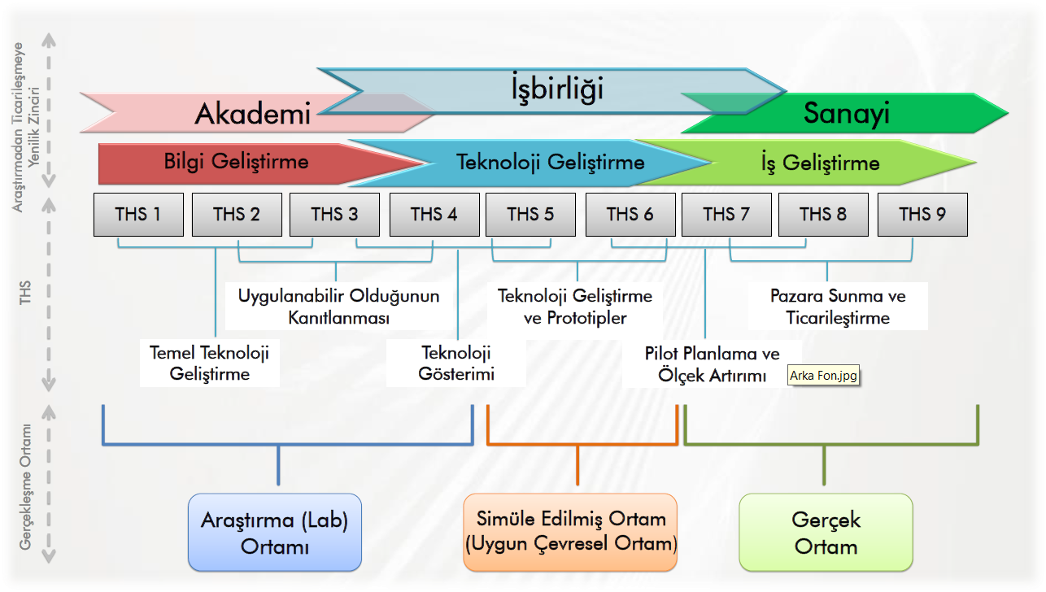



### Question: What is the purpose of doing a project?

* **Answer**: Projects create new opportunities to grow your business. You can finance your projects with support such as KOSGEB and help your business grow.



### Example:

* **A cafe owner**: “I want to grow my cafe but I don’t know how to start.”
  + Solution: By doing a project, you can buy new equipment and finance it with KOSGEB support.



## 2. How to Develop Your Business? (From Idea to Project)

### Question: How can I improve my business?

* **Answer**: Analyze your current business.
  + You can increase production,
  + offer new products, or
  + advertise to attract more customers.



### Question: How can I turn my ideas into projects?

* **Answer**: Identify your needs and think of solutions. For example, you can invest in digital marketing to attract more customers.



### Example:

* **A grocery store owner**: “I want to reach more customers.”
  + Solution: You can create a project, start online sales, and set up a website with KOSGEB support.



## 3. KOSGEB Support: Why Should You Apply?

### Question: What is KOSGEB support?

* **Answer**: KOSGEB is an institution that provides financial support to small and medium-sized businesses. You can apply for projects to get the money you need to develop your business.



### Question: Why should I get support from KOSGEB?

* **Answer**: You can get financial support to bring your projects to life faster and with less risk. This support can be used to buy new machinery, expand your business, or for marketing.



### Example:

* **A tailor**: “I want to take more orders but I can’t buy new machines.”
  + Solution: You can apply to KOSGEB and buy new sewing machines with the machinery-equipment support.



## 4. Preparing a Business Plan: Plan Your Project

### Question: What is a business plan?

* **Answer**: A business plan is a document that explains what your business will do in the future, how it will make money, and what it needs. A business plan is required for KOSGEB support.



### Question: How do I prepare a business plan?

* **Answer**: Write down what your business will do, what product or service it will offer, who it will target, and how you will carry out the project.

### Business Model Canvas

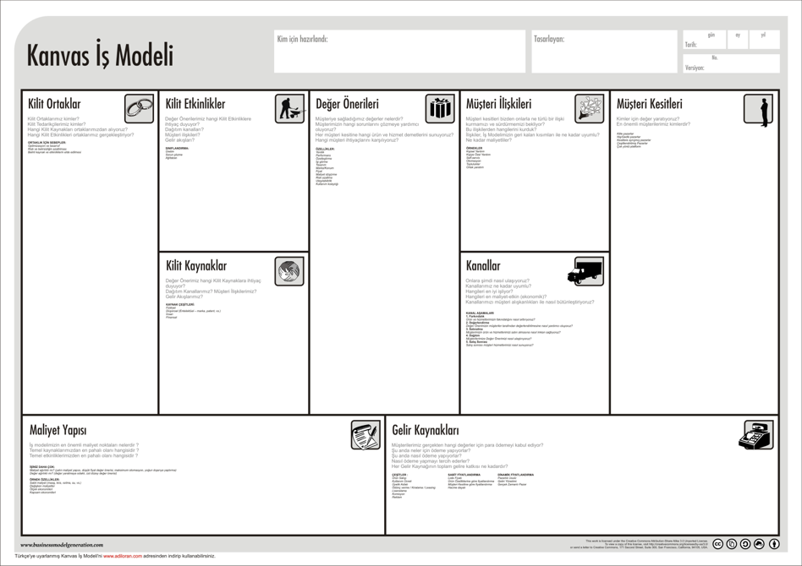



### Example:

* **A bakery owner**: “I want to buy new baking machines but don’t know where to start.”
  + Solution: In your business plan, explain the machines you need, why you need this investment, and how these machines will benefit your business.



## 5. Project Application Process: Step by Step

### Question: How can I apply to KOSGEB?

* **Answer**: To apply to KOSGEB, you first need to attend entrepreneurship training, then prepare your business plan and fill out the application forms.



### Application Steps:

1. Complete the entrepreneurship training.
2. Prepare your business plan.
3. Apply to KOSGEB.



### Example:

* **A butcher**: “What do I need to do to grow my business?”
  + Solution: After getting your entrepreneurship certificate and preparing your business plan, you can apply to KOSGEB for support.



## 6. R&D and Product Development (R&D/PD): Making Innovations

### Question: What is R&D?

* **Answer**: Research and Development (R&D) refers to the activities undertaken to develop new products or improve existing ones. KOSGEB supports R&D projects.



### Question: What is Product Development (PD)?

* **Answer**: Product Development (PD) focuses on improving existing products to increase your competitive edge in the market.



### Example:

* **A candy maker**: “I want to develop a new type of candy.”
  + Solution: You can test and develop your new product with R&D support.



## 7. Path to Market: Launching Your Product

### Question: How do I bring my product to market?

* **Answer**: You need to determine pricing, advertising, and sales channels to bring your product to market. KOSGEB also provides marketing support.



### Example:

* **A home goods store**: “How can I reach more people with my products?”
  + Solution: You can enter online sales platforms and use digital advertising with KOSGEB marketing support.



## 8. Advanced Information and In-Depth Explanations

### 8.1 Evaluate Your Business with a SWOT Analysis

#### Question: What are your business’s strengths and weaknesses?

* **Answer**: You may have high customer satisfaction, but your digital infrastructure might be lacking.



#### SWOT Table:

* **Strengths**: High-quality products, customer loyalty.
* **Weaknesses**: Lack of digital infrastructure, insufficient marketing.
* **Opportunities**: Transition to online sales, new customer base.
* **Threats**: Increasing number of competitors, changing market dynamics.



## 8.2 Shape Your Project with the Business Model Canvas

#### Question: What value do you offer to customers? (Value Proposition)

* **Answer**: You can offer value to customers through high quality, affordable prices, and fast delivery.



#### Example:

* **An e-commerce company**: “We offer fast delivery and reliable shopping.”
  + Solution: Improve your logistics infrastructure with KOSGEB support.



## 8.3 Develop Innovative Products and Technologies with R&D

#### What is the R&D Process?

* **Research**: Investigate customer demands and technological innovations.
* **Prototype Development**: Test and develop new product ideas.
* **Implementation**: Launch your products to the market and optimize production processes.



#### KOSGEB R&D Support

* **Machinery and Equipment Support**: Support for equipment used in R&D projects.
* **Personnel Support**: Hiring expert personnel for R&D projects.



## 8.4 Improve Your Existing Products with Product Development (PD)

#### What is Product Development (PD)?

* **Answer**: PD is the process of improving existing products or services to make them more competitive.



#### PD Stages

* **Customer Feedback**: Take customer feedback into account to improve your products.
* **Improvement and Redesign**: Make improvements that increase product quality.



## 8.5 Integrate SWOT and the Business Model Canvas

#### Question: How do you use SWOT and the Business Model Canvas?

* **Answer**: Analyze your business’s strengths and weaknesses with SWOT and create your business plan within a strategic framework using the Business Model Canvas.



#### Example:

* **A food manufacturer**: “How can I control costs while increasing production capacity?”
  + Solution: Use SWOT analysis to identify costs and the Business Model Canvas to plan new revenue streams.

## 9. Thank You!

#### Question and Answer Section



* Ask your questions about projects.
* For more information: [kosgeb.gov.tr](https://www.kosgeb.gov.tr)
* Check out the Frequently Asked Questions page
  + https://www.kosgeb.gov.tr/Web/Genel/SSS.aspx?KatID=2
* Entrepreneur Support Program
  + https://www.kosgeb.gov.tr/site/tr/genel/destekdetay/1231/girisimci-destek-programi
* You can get consultancy and support from chambers of commerce.

# From Idea to Market with KOSGEB Entrepreneur Support Program



Dr. UÄŸur CORUH

* General Manager of Coruh Arge ve Teknoloji
  + (ugur.coruh[*]coruh.com.tr)
* Assistant Professor, Computer Engineering Department, Recep Tayyip ErdoÄŸan University
  + (ugur.coruh[*]erdogan.edu.tr)